Medication Reminder and Adherence
Project Planning: Case Study, Methodology, Time Estimation, PERT and Gantt Charts

4. Case Study

4.1 Background
Many people take medication regularly, either for chronic conditions or for short treatment courses. In daily life, patients often forget to take a dose at the right time, especially when they are busy. Missed or delayed doses reduce the effectiveness of the treatment. The interview and questionnaire confirmed that users sometimes forget their medication and want a simple reminder system.

4.2 Problem Statement
Users depend on their own memory to take medication on time. There is no simple tool that reminds them, records whether the dose was taken, and reminds them again if the dose was missed.

4.3 Proposed System
Medication Reminder and Adherence is a system that helps users take their medication on time. The user enters the medication information, the system sends a reminder at the scheduled time, the user confirms the dose, and the system sends another reminder if the dose is not confirmed.

4.4 Objectives
- Reduce missed medication doses.
- Remind the user at the correct time.
- Let the user record that a dose was taken.
- Show the user a clear daily medication schedule.

4.5 Stakeholders and Users
Stakeholder | Role
Patient / Medication user | Main user: adds medication, receives reminders, confirms doses, views the schedule.
System analyst | Collects and analyses requirements and designs the system.
Developer / Tester | Builds and tests the system.

4.6 Scope
In scope: adding medication (name, dose, time); sending reminders; confirming a taken dose; repeating the reminder for a missed dose; displaying the daily schedule.
Out of scope (in this version): doctor or pharmacy integration, drug-interaction checking, and online payment.

4.7 Main Functional Requirements (from interview and questionnaire)
ID | Requirement
FR1 | The user can add medication name, dose, and time.
FR2 | The system sends a reminder at the scheduled time.
FR3 | The user can confirm that the medication was taken.
FR4 | The system reminds the user again if the dose is missed.
FR5 | The system displays the daily medication schedule.

5. Methodology

5.1 Selected Methodology: Waterfall (SDLC)
The project follows the Waterfall model of the System Development Life Cycle. Each phase is completed and reviewed before the next phase starts.
# | Phase | Work done in this project
1 | Planning | Define the problem, objectives, scope, and the project schedule.
2 | Analysis | Interview, questionnaire, and report; documenting requirements FR1 to FR5.
3 | Design | UML diagrams, database design, and user interface wireframes.
4 | Implementation | Build the database, interface, reminder module, confirmation and missed-dose logic, and schedule module.
5 | Testing | Integration and system testing against the requirements.
6 | Deployment and maintenance | Release the system, write documentation, and train users.

5.2 Why Waterfall?
- The requirements are clear and small (five main functions), and they are unlikely to change much.
- The project has a fixed set of phases, which makes time estimation, PERT, and Gantt charts easy to prepare.
- Each phase produces a document (report, design, test results), which suits an analysis and design project.
- The team is small and the system has low technical risk.

5.3 Fact-Finding Techniques Used
Interview (to understand the current problem in depth) and web form questionnaire (to collect opinions in a structured way). Both were used in the Analysis phase and are documented in sections 1 to 3.

6. Time Estimation
Duration of each activity is estimated using the three-point (PERT) formula:
Expected time (TE) = (O + 4M + P) / 6
where O = optimistic time, M = most likely time, and P = pessimistic time, all in working days. Assumption: a small team working about 5 days per week.
Activity | Description | Depends on | O | M | P | TE
A | Requirements gathering (interview & questionnaire) | - | 2 | 3 | 4 | 3.00
B | Requirements analysis & documentation | A | 2 | 3 | 5 | 3.17
C | System design (UML, database, UI wireframes) | B | 4 | 5 | 8 | 5.33
D | Database design & setup | C | 2 | 3 | 4 | 3.00
E | User interface development | C | 4 | 6 | 8 | 6.00
F | Reminder & notification module | D | 5 | 7 | 11 | 7.33
G | Confirmation & missed-dose reminder logic | F | 3 | 4 | 7 | 4.33
H | Daily medication schedule module | D, E | 2 | 3 | 5 | 3.17
I | Integration & system testing | G, H | 4 | 5 | 8 | 5.33
J | Deployment, documentation & user training | I | 2 | 3 | 4 | 3.00

Expected project duration: 34.5 working days, about 7 weeks.
Standard deviation along the critical path = 1.71 days. With about 95% confidence the project will finish within 37.8 days (about 8 weeks).

7. PERT Chart
The PERT chart shows the dependencies between activities. Each box shows the activity, its expected time (TE), earliest start (ES), earliest finish (EF), latest start (LS), and latest finish (LF).
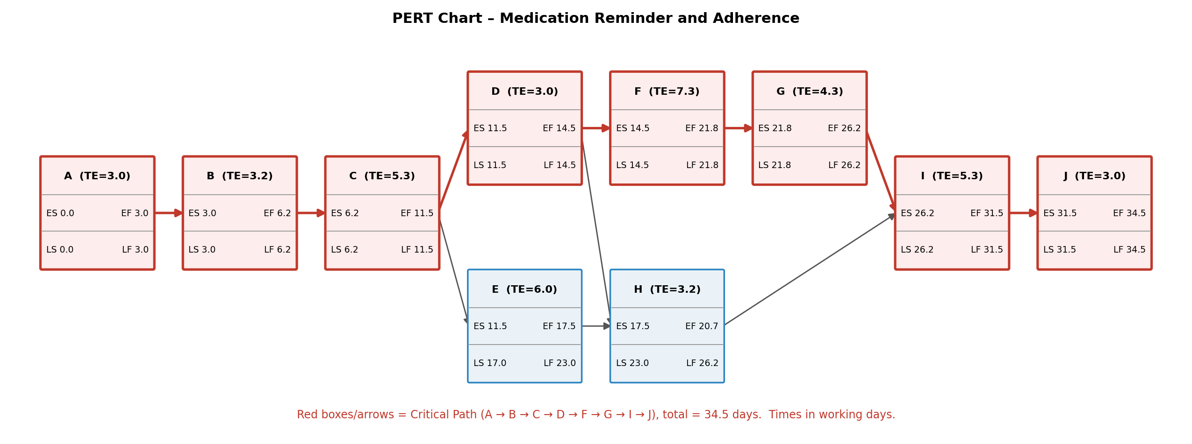

7.1 Slack and Critical Path
Activity | ES | EF | LS | LF | Slack | Critical?
A | 0.0 | 3.0 | 0.0 | 3.0 | 0.0 | Yes
B | 3.0 | 6.2 | 3.0 | 6.2 | 0.0 | Yes
C | 6.2 | 11.5 | 6.2 | 11.5 | 0.0 | Yes
D | 11.5 | 14.5 | 11.5 | 14.5 | 0.0 | Yes
E | 11.5 | 17.5 | 17.0 | 23.0 | 5.5 | No
F | 14.5 | 21.8 | 14.5 | 21.8 | 0.0 | Yes
G | 21.8 | 26.2 | 21.8 | 26.2 | 0.0 | Yes
H | 17.5 | 20.7 | 23.0 | 26.2 | 5.5 | No
I | 26.2 | 31.5 | 26.2 | 31.5 | 0.0 | Yes
J | 31.5 | 34.5 | 31.5 | 34.5 | 0.0 | Yes

Critical path: A → B → C → D → F → G → I → J. Total duration: 34.5 working days. Any delay in a critical activity delays the whole project. Activities E (User interface) and H (Daily schedule module) have 5.5 days of slack, so they can be delayed without affecting the finish date.

8. Gantt Chart
The Gantt chart shows the start and end of each activity on a time line. Red bars are critical activities, blue bars are non-critical activities, and the hatched area is slack.
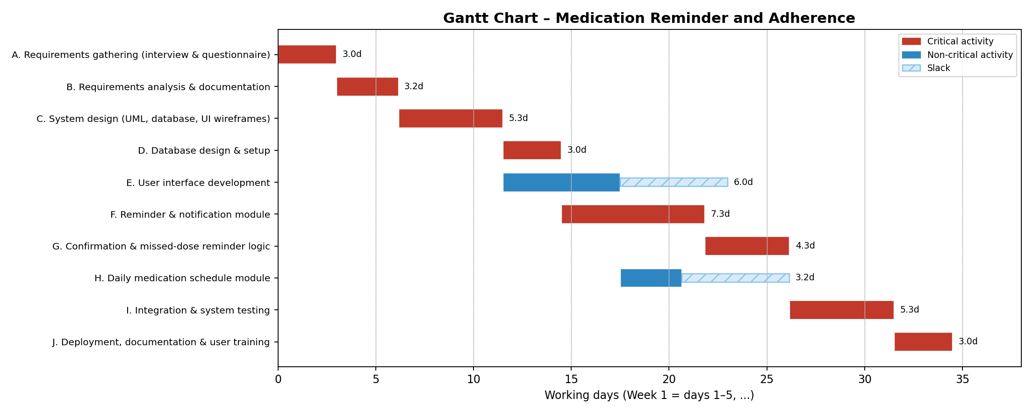

8.1 Weekly Schedule Summary
Period | Main work
Week 1 | A: Requirements gathering; start of B: Analysis
Week 2 | B: Analysis and documentation; start of C: System design
Week 3 | C: System design; D: Database setup; start of E: User interface
Week 4 | E: User interface; F: Reminder and notification module
Week 5 | F: Reminder module; H: Daily schedule module; start of G
Week 6 | G: Confirmation and missed-dose logic; start of I: Testing
Week 7 | I: Integration and system testing; J: Deployment, documentation, and training

